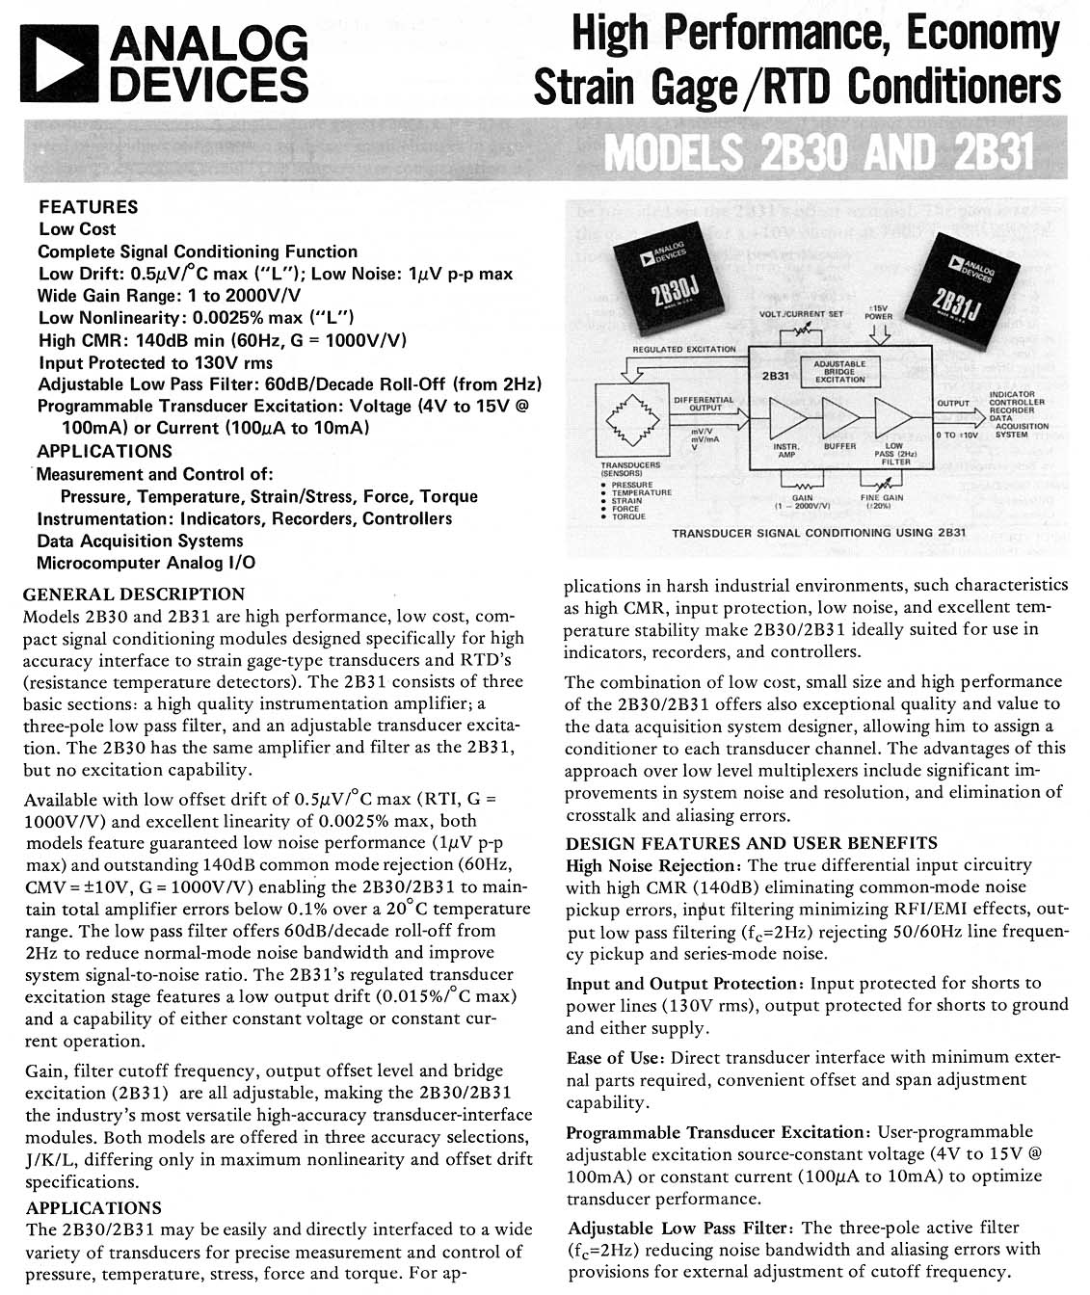
DC-DC CONVERTERS • CRT CORRECTION DEVICES • ISOLATION AMPLIFIERS • BATTERY CHARGERS
1400 Providence Hwy., Norwood, Massachusetts 02062
CALL TOLL FREE: 1-800-367-0004, TEL: (781) 551-5500, FAX: (781) 551-5555 www.intronicspower.com
®
an ISO9001 company
Manufactured by Intronics under exclusive agreement with Analog Devices
005-45003-00 REV. A JANUARY 2000

